PROJECT PROPOSAL

-Learning App for Preschoolers-

My learning app for preschoolers will be touch-based free app that is supposed to teach preschool kids new things. Users are assumed to be kids that don't know how to read so everything will be explained using icons and sound explanations. Target users are (future) English speakers. Although it is aimed for preschoolers it can be used by older persons that are about to start learning English language.

The app will have different categories that should teach kids different things and will not require any registration.

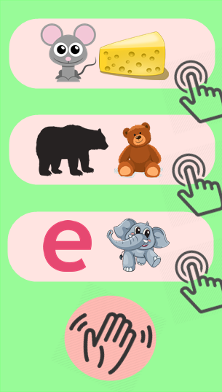First step will be designing an easy understandable menu that will include list of categories visually explained with no text. Every category will be opened by pressing large, simple button with icons describing that category. Menu will contain only those buttons and button for ending the app.

One of possible menu designs is shown on Figure 1.

Most probably the app will consist of three categories:

1. Matching animal with food that animal eats.

Animal will be presented by larger image and three options will be listed under. There will also be option to hear pronunciation and animal voices.

1. Matching single-colored figure with animal, plant or object. Figure will be simple, but the offered option don't need to be that same figure fully colored. It will also have a sound options. Another possibility is to have animal image or figure and to choose where it fits in offered images (considering its shape).

Figure Menu

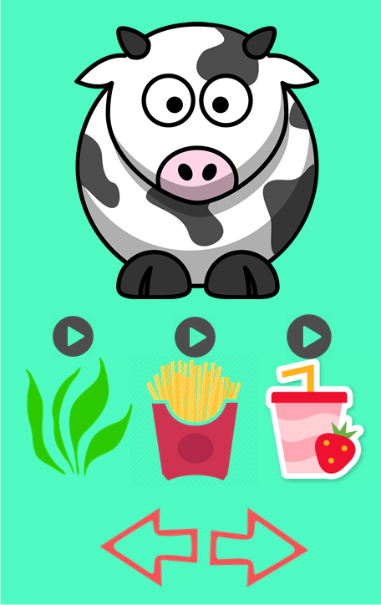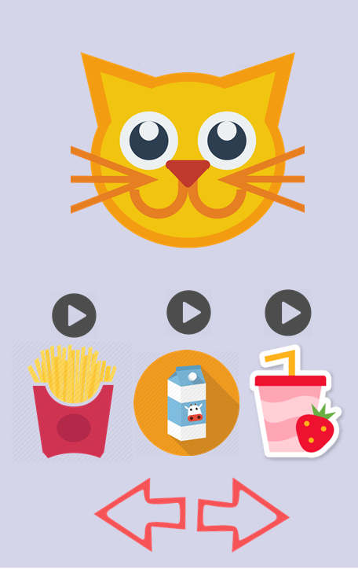

Figure

Figure

1. Matching letter with the image of animal, plant or object that starts with that letter. Both capital and small letters are included. There will be sounds for letters and pronunciation/spelling for offered images.

Figures 2 and 3 represent possible designs.

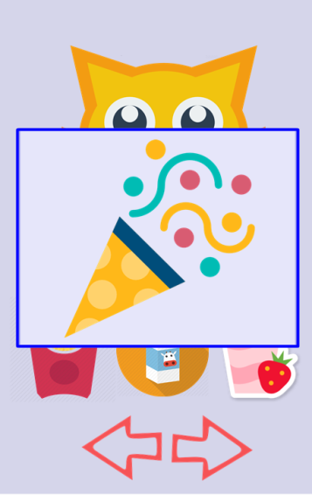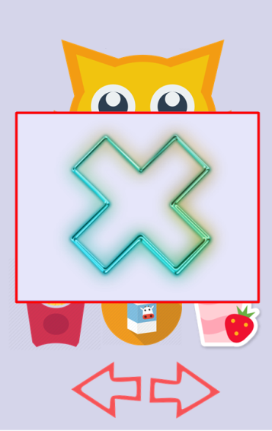

Figure

Figure

True or false will be announced by simple popup widow that can be closed by pressing anywhere. If the chosen option was correct then after closing the popup window app will proceed to next question and if the option was false user will stay on the same question to try again.

They are shown on figures 3 and 5.

Every window should have simple button for closing the app easily.

Navigation through the app can be done by using left and right arrows.

App will not have any levels so the user can do the same question more times in order to strongly remember learned things.

Amina Sinanović